
Department of Engineering Technology
Foundation University Islamabad
School of Science and Technology

Course: Introduction to Web Technology Lab
Lab III Manual
Name:
Roll no:

Topic: HTML Forms , Basic Style and Media Elements
Performance |  |  | Lab Report
Description | Total Marks | Marks Obtained | Description | Total Marks | Marks  Obtained
HTML Forms & Validation | 5 |  | Basic Style , Media Elements & Report | 5
Total Marks obtained

Lab Objectives
After completing this lab, students will be able to:
- Understand the concept of HTML forms
- Create different types of input fields
- Use form validation attributes
- Embed images, audio, and video in web pages
- Understand media controls in HTML
- Build interactive web forms with multimedia

What is an HTML Form?
An HTML Form is used to collect user input.
Example inputs include:
- Name
- Email
- Password
- Feedback
- File uploads
Forms send data to a server for processing.
The main HTML tag used is:
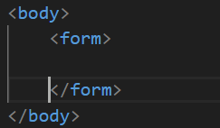
Inside the form we add different input elements.
Types of Input Fields
HTML provides many input types.
1 Text Input
Used to enter short text.
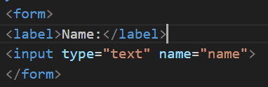
Output: A textbox where user types their name.

2 Password Input
Used to hide typed characters.
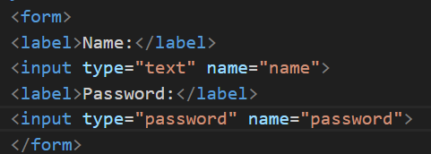

Output: Characters appear as dots or stars.

3 Email Input
Used to enter email address.

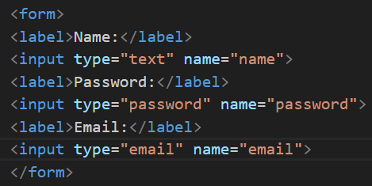

Browser checks if email format is correct.
Example:
example@gmail.com

4 Number Input
Used to enter numeric values.

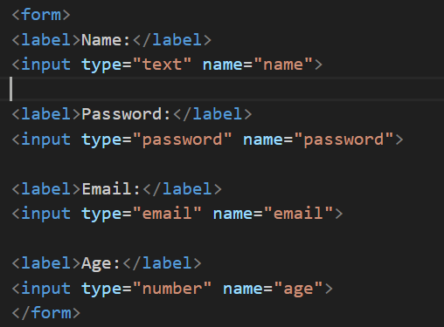
Browser provides increase/decrease arrows.

5 Radio Buttons
Used when only one option can be selected.
Example: Gender selection.

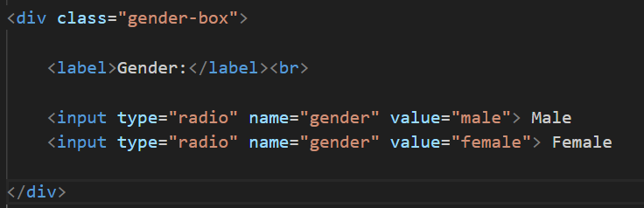
Only one option can be chosen.

6 Checkboxes
Used when multiple options can be selected.
Example: Skills

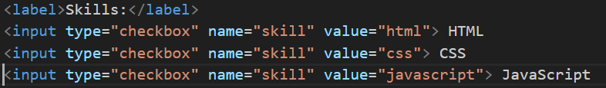
User can choose multiple skills.

7 Dropdown List
Created using <select> tag.

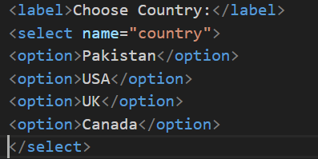
User selects one option from the list.

8 Textarea
Used for long messages or feedback.

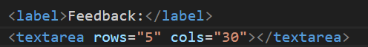
Used for:
- Comments
- Reviews
- Messages

9 File Upload
Used to upload files.

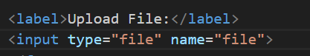
Used for:
- Resume
- Documents
- Images

Form Buttons
Submit Button
Used to submit the form.
Reset Button
Clears all form fields.

Form Validation
HTML provides built-in validation.
Required Field
Ensures user fills the field.

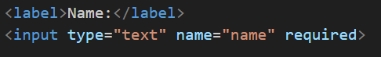
If empty, browser shows error.

HTML Media Elements
HTML allows embedding multimedia like:
- Images
- Audio
- Video

Images are added using <img> tag.

Attributes
Attribute | Description
src | Image path
width | Image width
height | Image height
alt | Alternate text

Audio in HTML
HTML5 introduced <audio> tag.

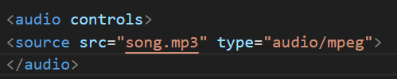
Attributes
Attribute | Description
controls | Shows play/pause buttons
autoplay | Automatically plays audio
loop | Repeats audio
Video in HTML
Videos are added using <video> tag.
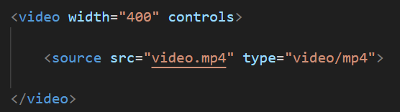
Attributes
Attribute | Description
controls | Show video controls
autoplay | Auto play
loop | Repeat video
poster | Image before video starts

Add CSS Section
Inside the <head> tag add a style section.

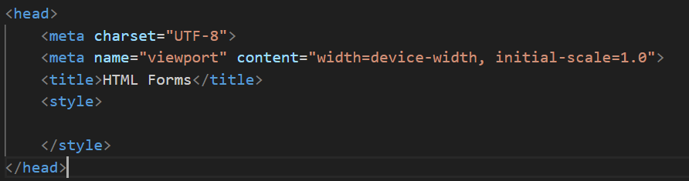
This is where we will add form styling.

Style the Page Background
Add background color and font.

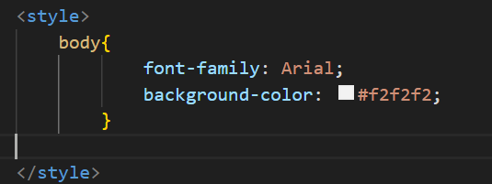

Property | Purpose
font-family | Changes text style
background-color | Changes page background

Style the Form Container
Center the form and add a box style.

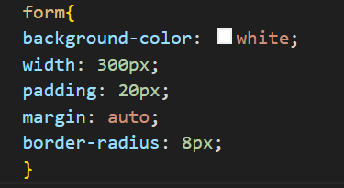
Property | Purpose
width | Form width
padding | Space inside form
margin:auto | Center form
border-radius | Rounded corners

Style the Labels
Make labels more readable.

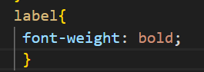
This makes the label text bold.

Style Input Fields
Improve textboxes.
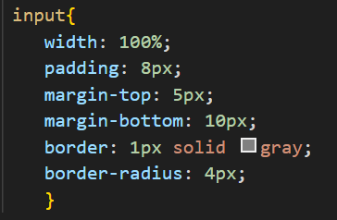

Property | Purpose
width:100% | Input fills form width
padding | Space inside field
margin-bottom | Space between inputs
border-radius | Rounded input boxes

Style the Submit Button
Make the button attractive.
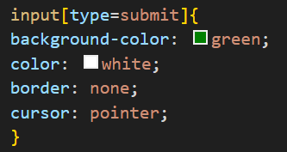

Property | Purpose
background-color | Button color
color | Text color
border:none | Removes border
cursor:pointer | Hand cursor on hover
Add Button Hover Effect
Add interaction.

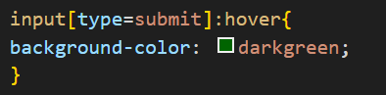
When user moves mouse over button - color changes.

Lab Report Guidelines
Report Format and Sections:
- Make sure your report is well-organized and easy to follow.
- Use proper headings for each section mentioned above.
- Include screenshots wherever required to demonstrate progress and outputs including Figure Captions.
- Submit the lab report as a document file (Only Word)
- In next Lab You must Submit your Previous lab Report in Printed Form

